Test Case: tc001_SPX_Dev5_Crear_Solicitud_Articulo_Almacen
Step 1 - Enter username and password and click to button Enter : Credentials Entered
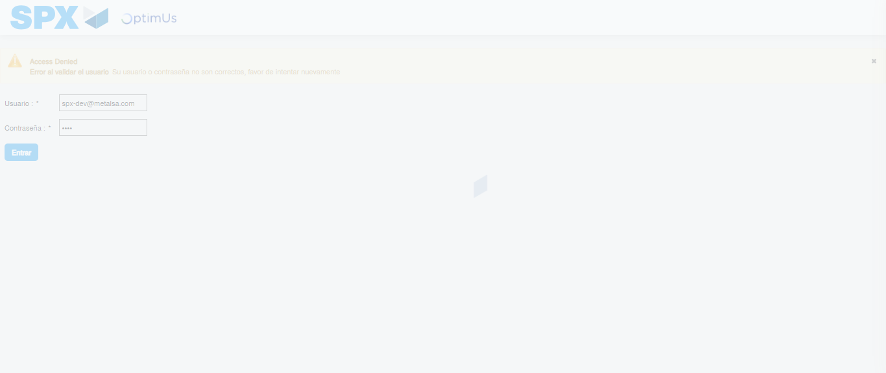Image file-name: QC_Testing-tc001_SPX_Dev5_Crear_Solicitud_Articulo_Almacen-1787935482500

Step 2 - Select to UEN and Access to Request for a New Inventory Item : UEN Correctly selected and Correct access
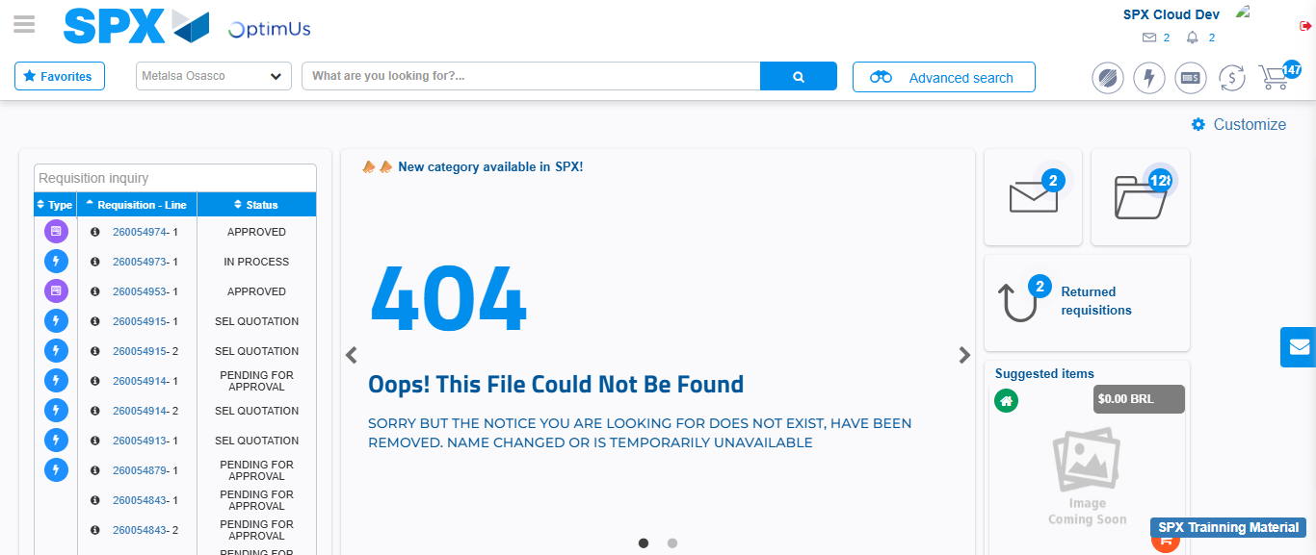Image file-name: QC_Testing-tc001_SPX_Dev5_Crear_Solicitud_Articulo_Almacen-1787935539494

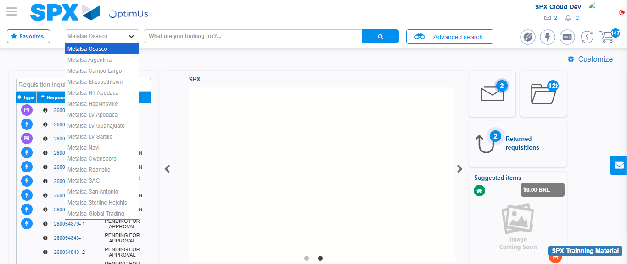Image file-name: QC_Testing-tc001_SPX_Dev5_Crear_Solicitud_Articulo_Almacen-1787935540249

Image file-name: QC_Testing-tc001_SPX_Dev5_Crear_Solicitud_Articulo_Almacen-1787935550066

Step 3 - Select options first section : Options seleted correctly
Image file-name: QC_Testing-tc001_SPX_Dev5_Crear_Solicitud_Articulo_Almacen-1787935550372

Image file-name: QC_Testing-tc001_SPX_Dev5_Crear_Solicitud_Articulo_Almacen-1787935550577

Step 4 - Select options at Screen: Options seleted correctly
Image file-name: QC_Testing-tc001_SPX_Dev5_Crear_Solicitud_Articulo_Almacen-1787935550372

Image file-name: QC_Testing-tc001_SPX_Dev5_Crear_Solicitud_Articulo_Almacen-1787935550577

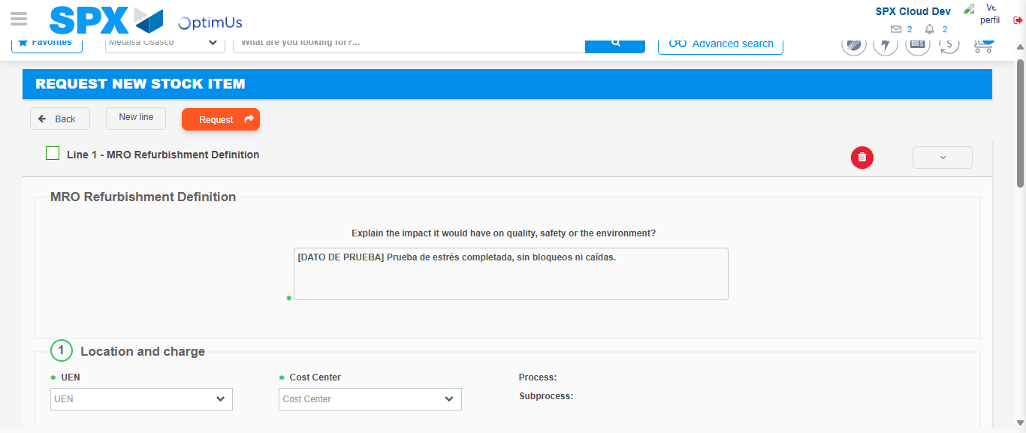Image file-name: QC_Testing-tc001_SPX_Dev5_Crear_Solicitud_Articulo_Almacen-1787935563890

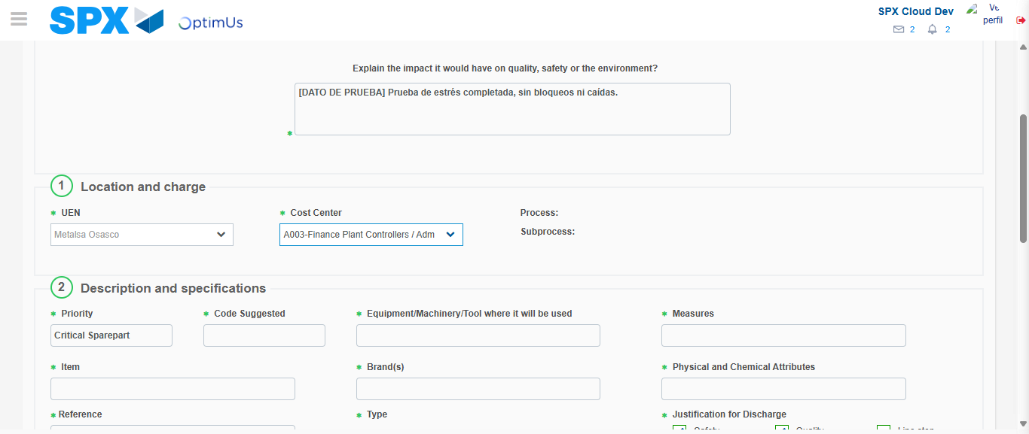Image file-name: QC_Testing-tc001_SPX_Dev5_Crear_Solicitud_Articulo_Almacen-1787935566746

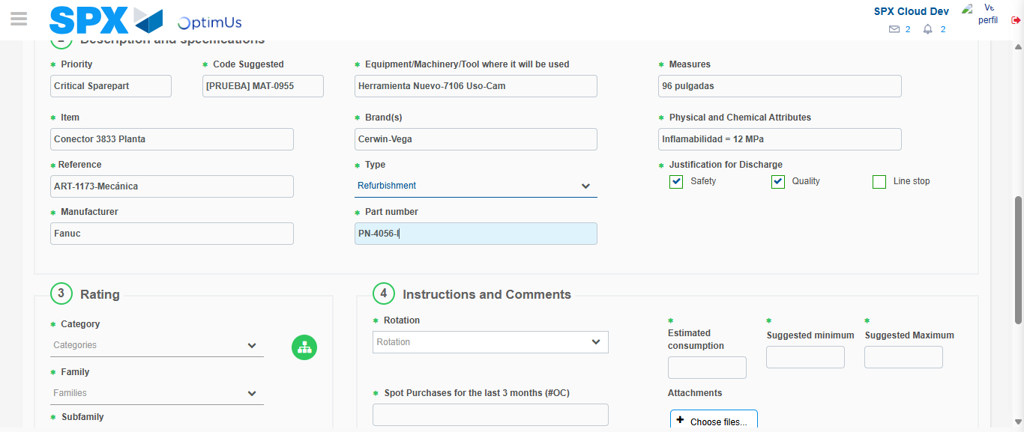Image file-name: QC_Testing-tc001_SPX_Dev5_Crear_Solicitud_Articulo_Almacen-1787935568803

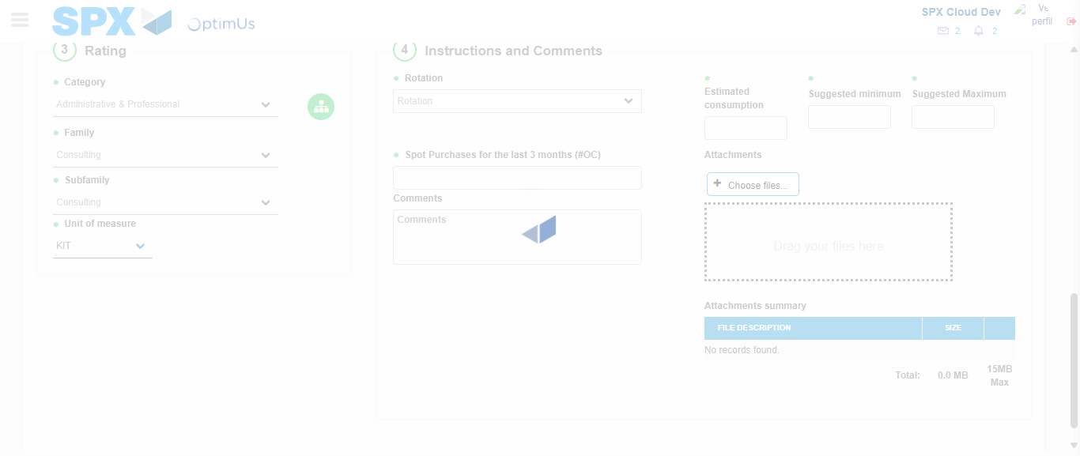Image file-name: QC_Testing-tc001_SPX_Dev5_Crear_Solicitud_Articulo_Almacen-1787935573778

Step 5 - Request New Item : Request Accepted
Image file-name: QC_Testing-tc001_SPX_Dev5_Crear_Solicitud_Articulo_Almacen-1787935539494

Image file-name: QC_Testing-tc001_SPX_Dev5_Crear_Solicitud_Articulo_Almacen-1787935540249

Image file-name: QC_Testing-tc001_SPX_Dev5_Crear_Solicitud_Articulo_Almacen-1787935550066

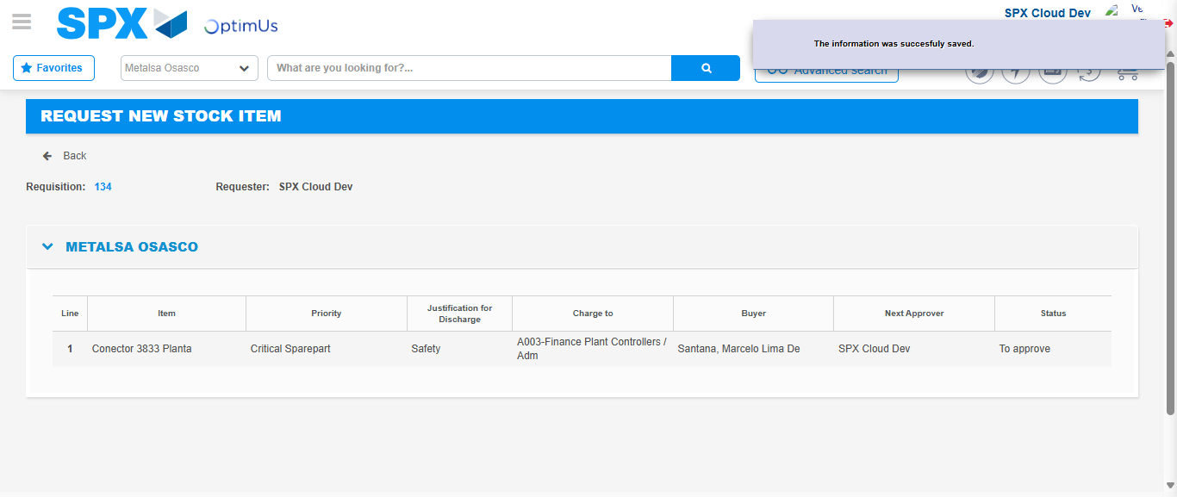Image file-name: QC_Testing-tc001_SPX_Dev5_Crear_Solicitud_Articulo_Almacen-1787935581024

Image file-name: QC_Testing-tc001_SPX_Dev5_Crear_Solicitud_Articulo_Almacen-1787935581231

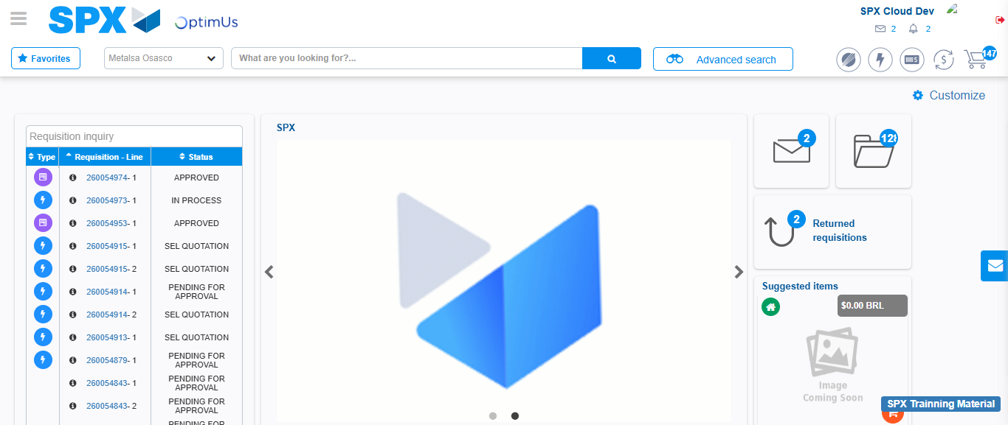Image file-name: QC_Testing-tc001_SPX_Dev5_Crear_Solicitud_Articulo_Almacen-1787935602582

Step 7 - Return to Main Page SPX : Return to Main Page SPX
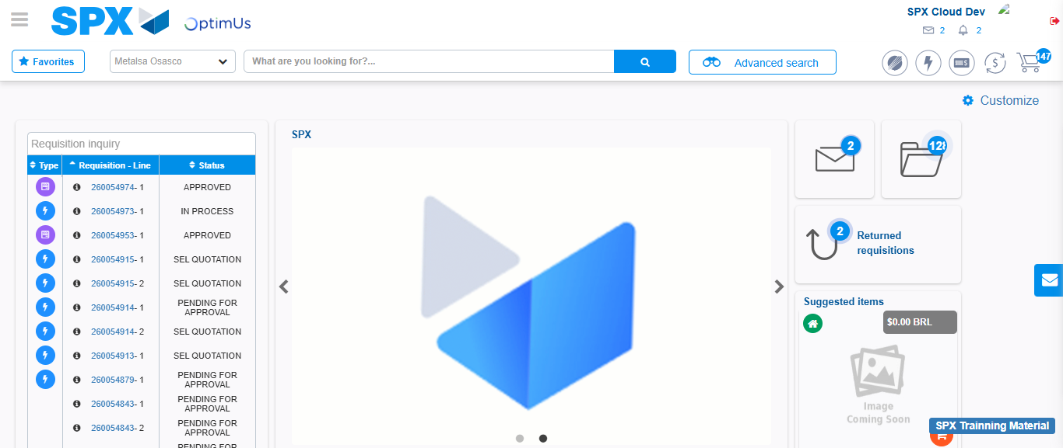Image file-name: QC_Testing-tc001_SPX_Dev5_Crear_Solicitud_Articulo_Almacen-1787935602931

